International journal of Science, Engineering & Environmental
Technology (IJOSEET), 1(1): 8-15, 2016
ISSN xxxxxx

Title of Your Paper, Capitalize First Letter
First Authourª*, Second Authour^{b}, Third Authour^{c}
ª ^{aFirst}
^{b} ^{bSecond}

Abstract – Abstract should not exceed 250 words and should concisely state what was done, how it was done, principal results, and their significance and/or contributions. It should be also noted that abstract should not contain any equations, references, or footnotes.

Keywords: The author shall provide up to 6 keywords (in alphabetical order) to help identify the major topics of the paper.
- Introduction
This document may be used as a template as well as the guidelines for prospective authors who will have to prepare the final manuscript accepted for publication by IJOSEET or ICONSEET. You may type over sections of the document, cut and paste into it, and/or use markup styles Section headings
Section headings should be left justified, with the first letter capitalized and numbered consecutively, starting with the Introduction. Sub-section headings should be in capital and lower-case italic letters, numbered 1.1, 1.2, etc, and left justified.
  - General guidelines for the preparation of your text
Avoid hyphenation at the end of a line. Symbols denoting vectors and matrices should be indicated in bold type. Scalar variable names should normally be expressed using italics. Weights and measures should be expressed in SI units.
  - Footnotes
Footnotes should be avoided. Necessary “footnotes” should be composed directly in the text, instead of footnote style.
- Author Artwork
All figures and tables should be numbered with Arabic numerals (1,2,...n). All photographs, schemas, graphs and diagrams are to be referred to as figures. Line drawings should be good quality scans or true electronic output. Low-quality scans are not acceptable. Figures and tables must be embedded into the text and not supplied separately. Lettering and symbols should be clearly defined either in the caption or in a legend provided as part of the figure. Figures and tables should be placed at the top or bottom of a page wherever possible, as close as possible to the first reference to them in the paper.
The figure number and caption should be typed below the illustration in 9pt and left justified. However, if two images fit next to each other, these may be placed next to each other to save space, see Fig. 1. They must be numbered consecutively, all figures, and all tables respectively.

Figure axis labels are often a source of incompleteness. All coordinate graphs should have the axis labels: physical quantity with unit in parentheses, as shown in Fig. 1.
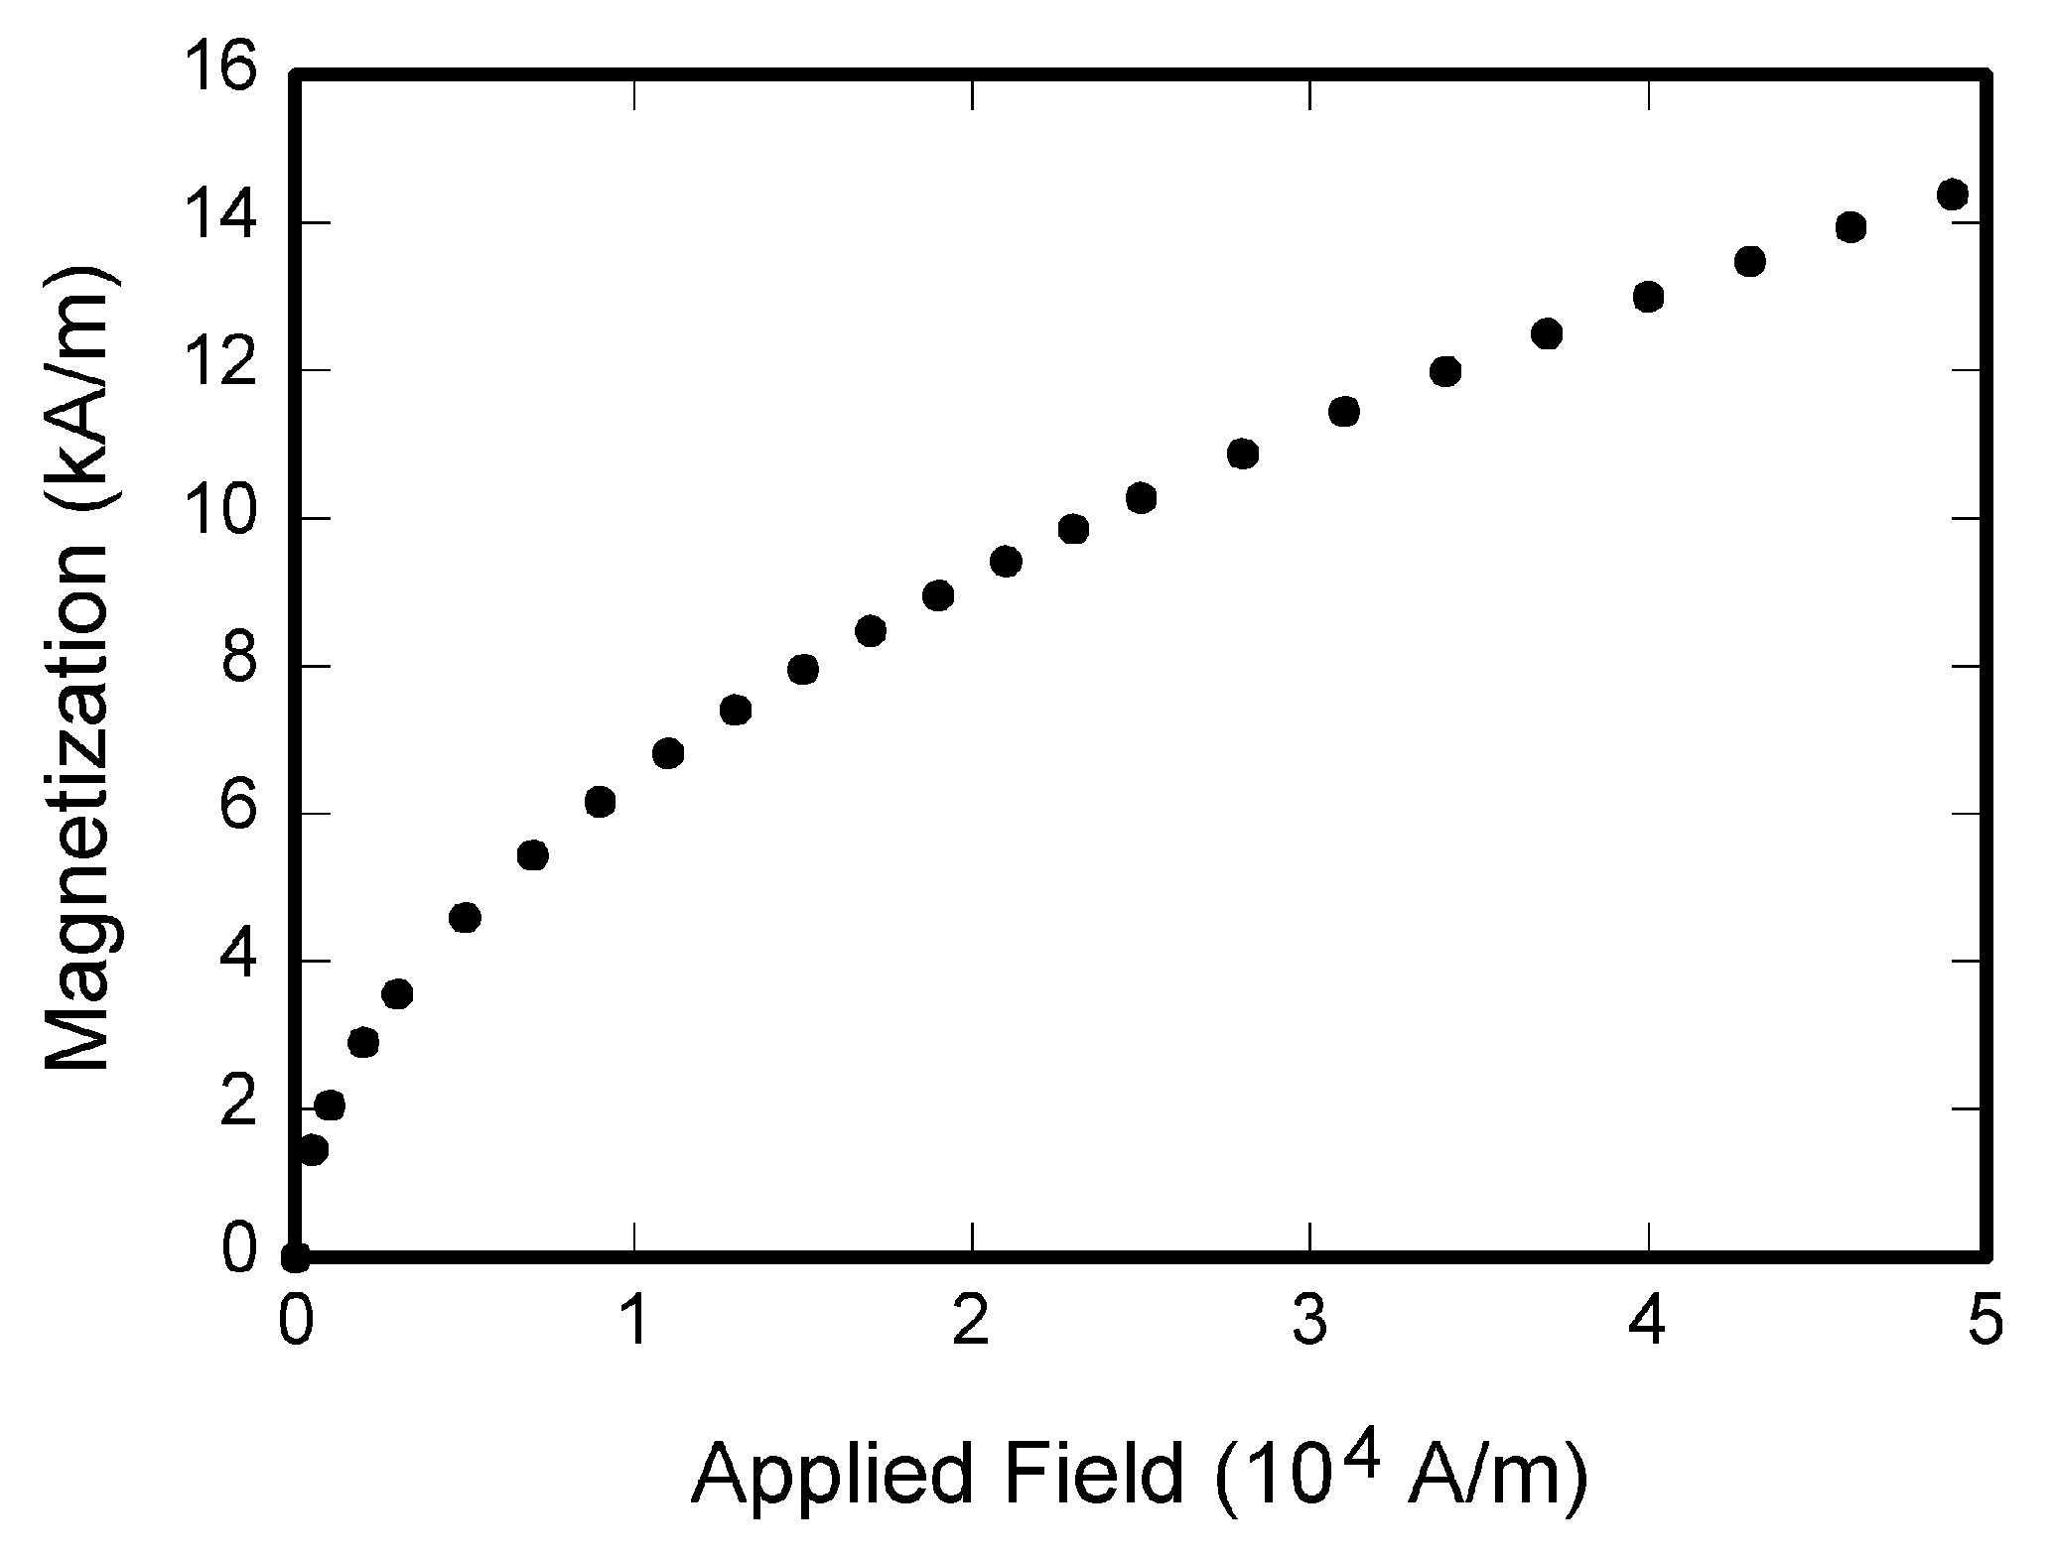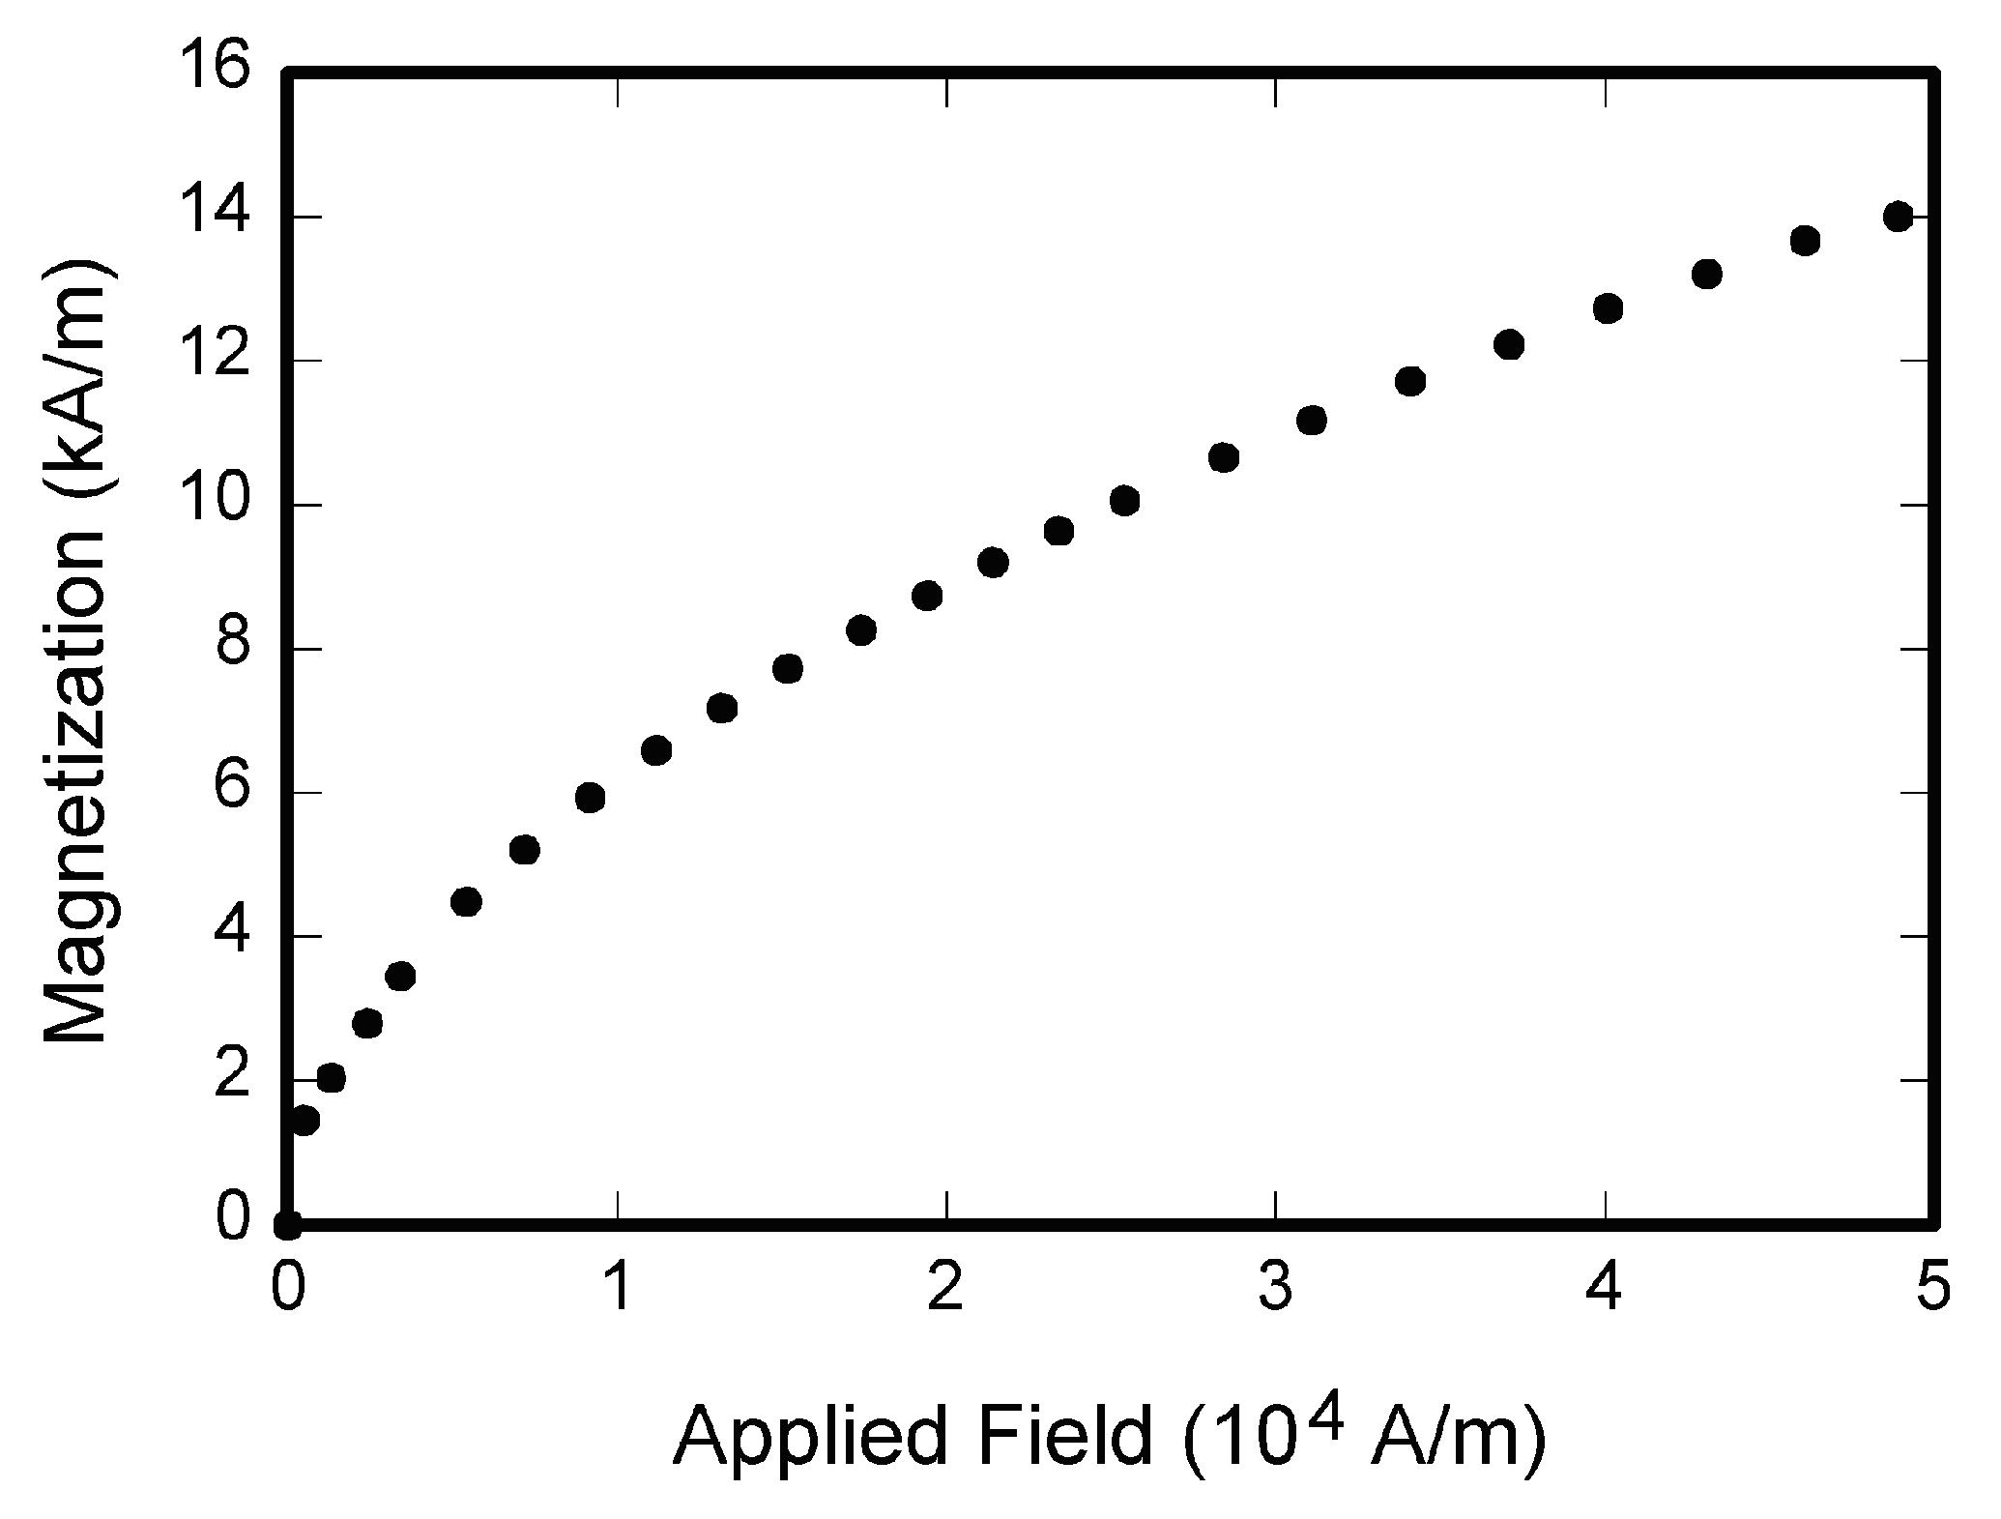
(a) (b)
Fig. 1. Magnetization as a function of applied field: (a) condition 1and (b) condition 2.

The table number and caption should be typed below the illustration in 9pt and left justified.

Table 1. The caption must be followed by the table
S/No. | Current (amp) | Voltage (volts
a | 0.85 | 0.97
b | 1.46 | 1.89

- Math and Equations
Use either the Microsoft Equation Editor or the MathType commercial add-on for MS Word for all math objects in your paper (Insert | Equation or MathType Equation). "Float over text" should not be selected. Number equations consecutively with equation numbers in parentheses flush with the right margin, as in (1). Be sure that the symbols in your equation have been defined before the equation appears or immediately following.
$P_{L_{i,t}}= \sum_{j=1}^{N}{\left[α_{\text{ij},t}\left(P_{i,t}P_{j,t}+Q_{i,t}Q_{j,t}\right)+β_{\text{ij},t}\left(Q_{i,t}P_{j,t}+P_{i,t}Q_{j,t}\right)\right]}$ (1)
Where P_{Li,,t} is the total power loss, P_{i,t} and Q_{i,t} are the net active and reactive power injection at bus i at time t.
- Abbreviations and Acronyms
Define less common abbreviations and acronyms the first time they are used in the text, even after they have been defined in the abstract. Abbreviations such as SI, MKS, CGS, ac, dc, and rms do not have to be defined. Do not use abbreviations in the title unless they are unavoidable.
- Copyright
All authours must sign the Transfer of Copyright agreement before the article can be published. This transfer agreement enables the publisher to protect the copyrighted material for the authours, but does not relinquish the authours' proprietary rights. The copyright transfer covers the exclusive rights to reproduce and distribute the article, including reprints, photographic reproductions, microfilm or any other reproductions of similar nature and translations. Authours are responsible for obtaining from the copyright holder permission to reproduce any figures for which copyright exists.
Acknowledgements
These and the Reference headings are in bold but have no numbers. Text below continues as normal.
References (in 9pt)
Journal Paper Format:
[1] Petinrin J.O. and Shaaban M. Renewable energy for continuous energy sustainability in Malaysia. Renew Sustain Energy Rev 2015;50:967–81.
Book Format:
[2] Clarke E, Circuit Analysis of AC Power Systems, vol. I. New York: Wiley, 1950, p. 81.
Paper (within a Book with Editors) Format:
[3] Dabara GR and Adebayo LB. How to prepare an electronic version of your article. In: Jones BS, Smith RZ, editors. Introduction to the Electronic Age, New York: E-Publishing Inc; 1999:281–304.
Conference Paper with pages Format:
[4] Asimi C, Kelechi M, Samson PW, Dauda A, McCalley JD, Tajudeen WT. Professional resources to implement the smart grid. In: Proc. of North American Power Symposium, 2009:1–8.
Web Material Format:
[6] Olalude J. (November 2009). Killerbee: practical zigbee exploitation framework. [Online]. Available: http://www.willhackforsushi.com/presentations/toorcon11-wright.pdf
Thesis or Dissertation Format
[7] Wolepet J. Narrow-band analyzer. PhD dissertation. Department of Electrical Engineering, Excellent University. Ipetu Ijesa, Nigeria; 2015.
Appendix A: An example appendix
Authors including an appendix section should do so after References section. Multiple appendices should all have headings in the style used above. They will automatically be ordered A, B, C etc.
  - Example of a sub-heading within an appendix
There is also the option to include a subheading within the Appendix if you wish.

